

**Kauno technologijos universitetas**

fACULTY OF INFORMATICS

**T120B166 Development of Computer Games and Interactive Applications**

*Party Table Game - Saboteur*

IFF-6/11 Nerijus Dulkė

Date: 2019.05.28

KAUNAS

2019

**Contents**

Table of images 3

Game description 4

Laboratory work #3 5

List of tasks 5

Solution 5

Task #1. Add menu system 5

Task #2. Options 6

Task #3. GUI elements 7

Task #4. Not implemented 8

Task #5. Not implemented 8

Task #6. Not implemented 8

Task #7. Spawn points 8

Task #8. Scoring system 8

Task #9. Game over condition 9

Task #10. Highscores 11

Defense task 12

Literature list 12

# Table of images

Figure 1 Main menu 5

Figure 2 Options menu 6

Figure 3 GUI 7

Figure 4 Grid of invisible objects set as spawnpoints 8

Figure 5 Score display 9

Figure 6 Game over screen 10

Figure 7 Highscore view 11

# Game description

1. **3D or 2D?** 3D
2. **What type is your game?** Board sgame
3. **What genre is your game?** Party game
4. **Platforms:** PC
5. **Scenario description:** In this game action is set in a mine. Players take on the role of dwarves, some are miners, some are saboteurs, but no one knows who is on their side. For miners goal is to get to the gold until the cards run out. For saboteurs the goal is to stop miners from reaching gold. After three rounds the player with the most gold wins.

# Laboratory work #3

## List of tasks

1. Add menu system
2. Options
3. Have GUI elements
4. Attack mechanics
5. AI implementation
6. Health/Power ups
7. 5 spawn points
8. Scoring system
9. Game over condition
10. High scores

## Solution

### Task #1. Add menu system

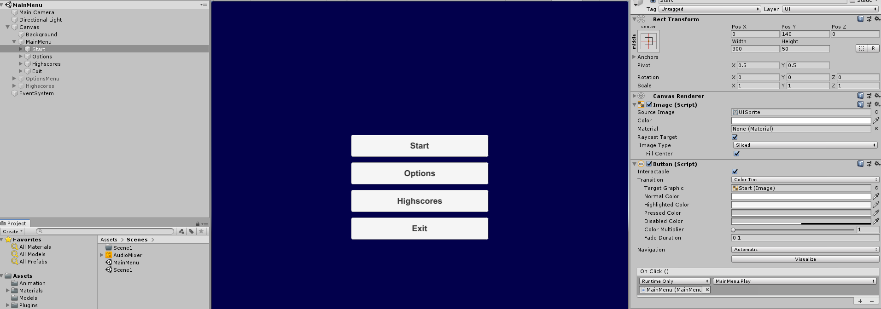

Figure 1 Main menu

Added menu system:

* Start – move to main scene and start the game
* Options – open options menu
* Highscores – show highscores
* Exit – quit game

### Task #2. Options

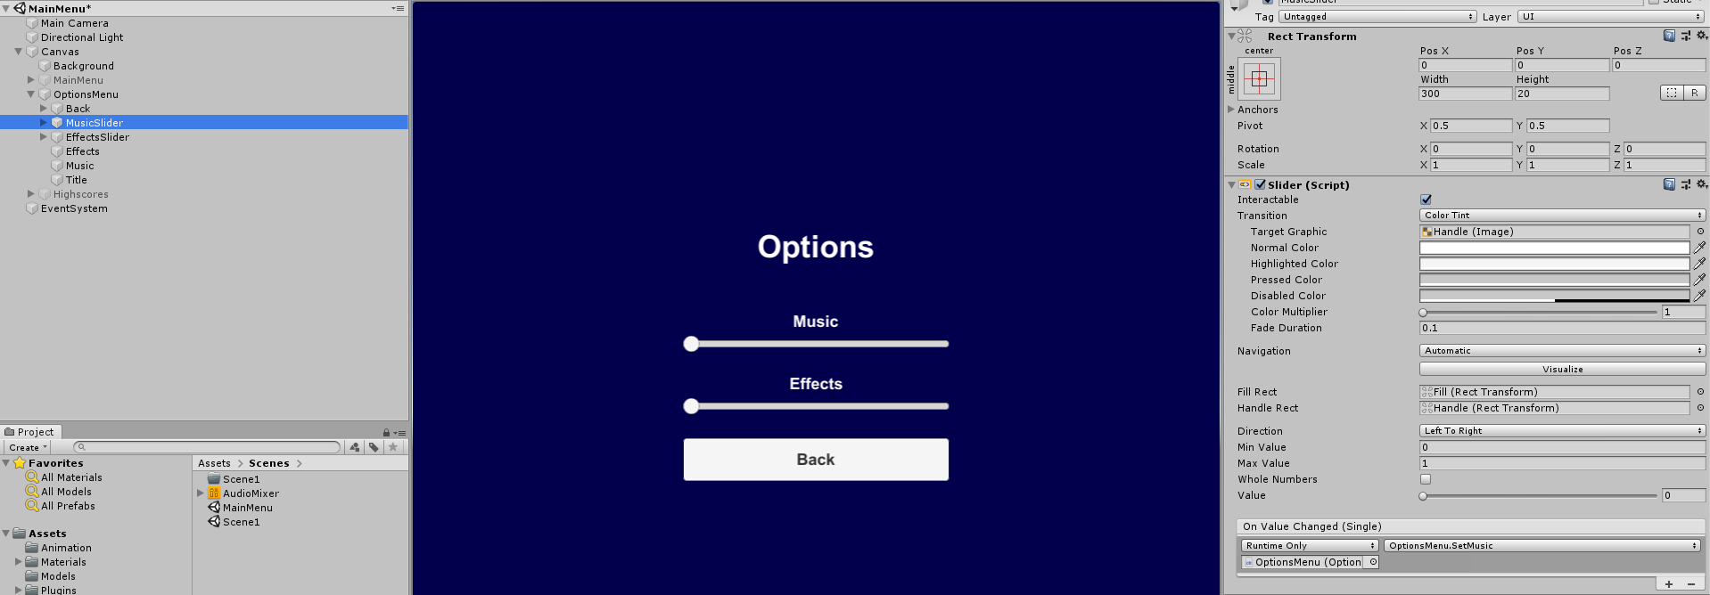

Figure 2 Options menu

Options menu contains settings for music and effects volume.

### Task #3. GUI elements

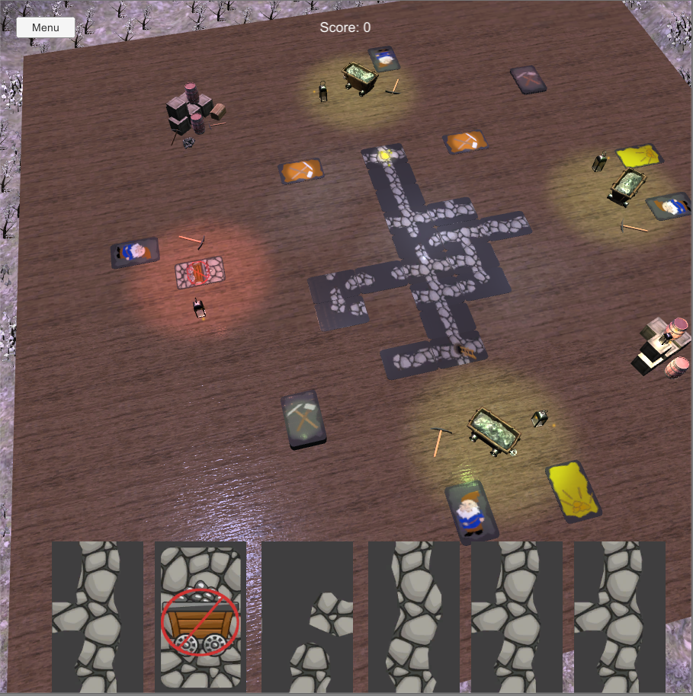

Figure 3 GUI

There are 3 main GUI elements:

* Menu button (top left)
* Current score (top center)
* Current cards in player’s hand (bottom)

### Task #4. Not implemented

### Task #5. Not implemented

### Task #6. Not implemented

### Task #7. Spawn points

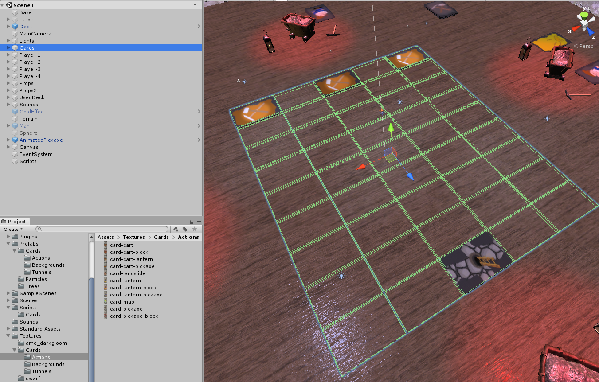

Figure 4 Grid of invisible objects set as spawnpoints

Spawn points for cards are invisible objects across the grid. Cards are instantiated from prefabs.



### Task #8. Scoring system

In this game score is gold. After every match winner gets 1-5 gold. The players with highest score after 3 matches wins.

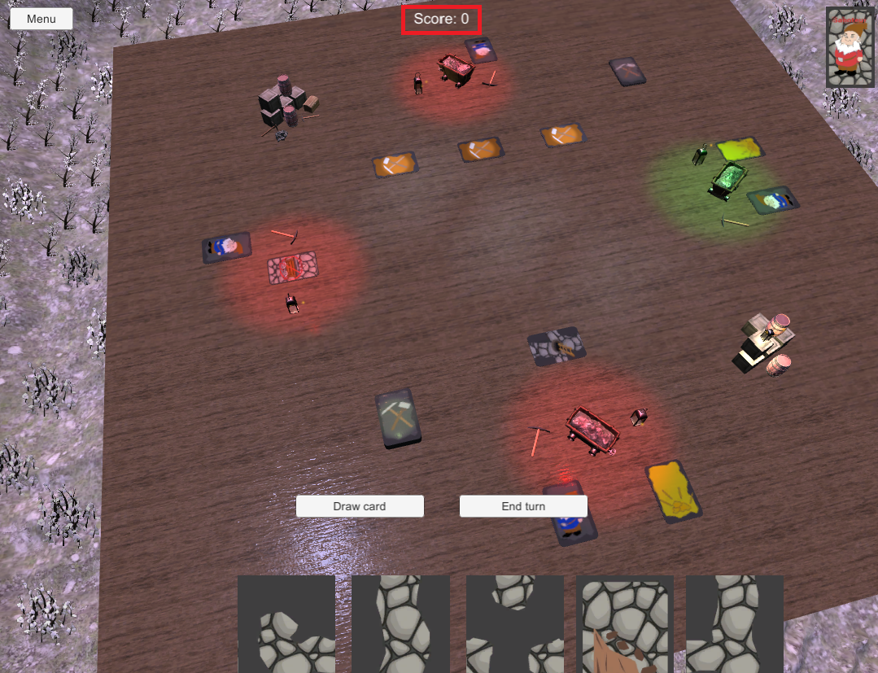

Figure 5 Score display

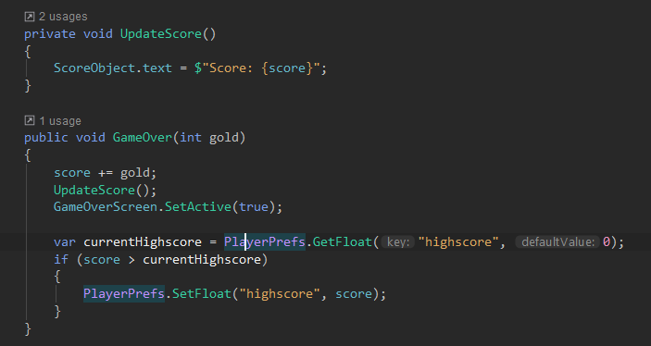

### Task #9. Game over condition

Game is over when dwarfs reaches gold or runs out of cards. Random number of gold (1-5) is given for the winners.

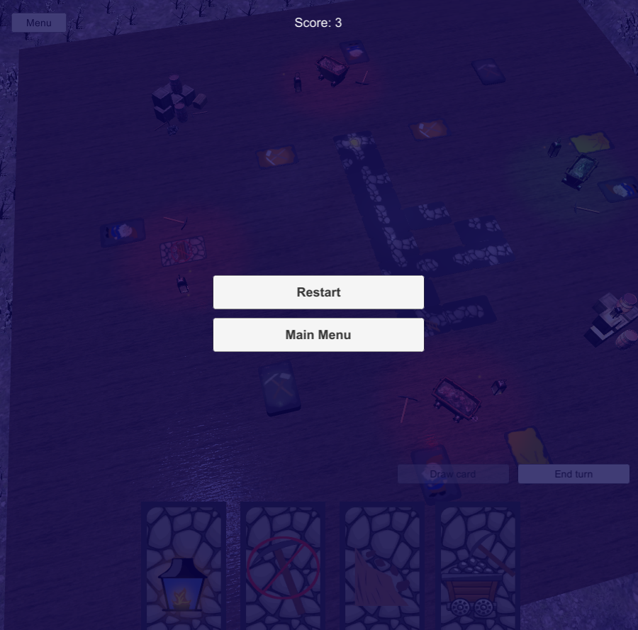

Figure 6 Game over screen

When player gets to the finnish card, it is fliped and if it has gold it is added to the score and game is over.

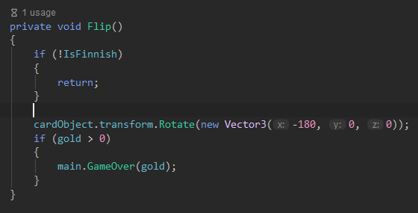

### Task #10. Highscores

Highscore is saved in player prefs, and updated after every game.

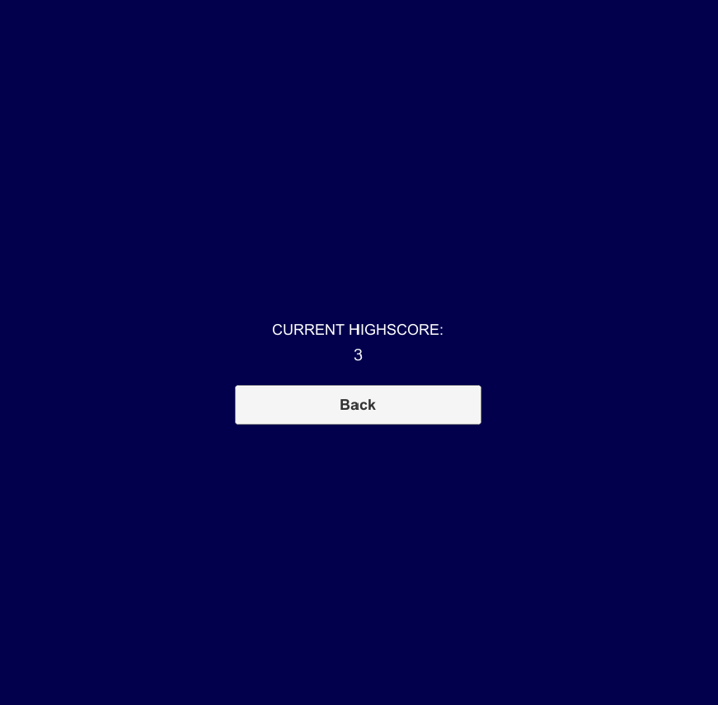

Figure 7 Highscore view

var currentHighscore = PlayerPrefs.GetFloat("highscore", 0);  
if (score > currentHighscore)  
**{** PlayerPrefs.SetFloat("highscore", score);  
**}**

### Defense task

Update code so every player has a card with a straight tunnel.

Added extra card with UP and DOWN connections for every player on start.

var cc = AllCards.FirstOrDefault(x =>  
 x.connections.Contains(Card.Directions.**Up**) && x.connections.Contains(Card.Directions.**Down**));  
for (var i = 0; i < Players.Count; i++)  
**{** Players[i].Id = i;  
 Players[i].DropHand();  
 for (var j = 0; j < 5; j++)  
 {  
 Players[i].AddCard(DrawCardFromDeck());  
 }  
 Players[i].AddCard(cc);  
}

# Literature list

Resources used from:

* <https://www.textures.com/download/pbr0139/133174>
* <https://www.textures.com/download/3dscans0079/128150>
* <https://www.freelancer.com/contest/Concept-Art-SKETCH-Gnome-390351-byentry-8768095>
* <https://www.freepik.com/free-vector/cartoon-stone-texture_976364.htm>
* <https://www.vectorstock.com/royalty-free-vector/mine-cart-with-coal-vector-1747485>
* <https://all-free-download.com/free-vector/download/treasure-map-clip-art_23028.html>
* <https://www.kisspng.com/png-cartoon-ladder-illustration-cartoon-wooden-ladder-497343/>
* <https://www.turbosquid.com/3d-models/pickaxe-obj-free/912027>
* <https://sketchfab.com/3d-models/mine-cart-2beeab5f44704421bc10cd310db96860>
* <https://www.textures.com/download/3dscans0110/130564>
* <https://www.textures.com/download/pbr0031/133067>
* <https://sketchfab.com/3d-models/lantern-final-aead6bb3bab344eaab541c5ac52c657c>
* <https://sketchfab.com/3d-models/40-rocks-a6c5ab5b438f473cb1cafdf4099e1657>
* <https://free3d.com/3d-model/crate-86737.html>
* <https://free3d.com/3d-model/barrel-7685.html>
* <https://free3d.com/3d-model/wooden-chest-44006.html>
* sounds from <https://www.productioncrate.com> and <https://www.zapsplat.com>
* <https://www.textures.com/download/pbr0172/133207>
* <https://www.textures.com/download/asphaltcloseups0064/12319>
* <http://www.custommapmakers.org/skyboxes.php>
* <https://sketchfab.com/3d-models/elysiumvr-male-character-rigged-template-4d0f03c673474921804254658666710d>